MAILBOX ALERT SYSTEM

Use Case Specification: Letter Detection

Version 1.0

Revision History

|  |  |  |  |
| --- | --- | --- | --- |
| **Date** | **Version** | **Description** | **Author** |
| 30/03/2017 | 1.0 | Use Case for Mailbox Alert system | K.Sriram  N.Vignesh  J.Sachin Fernandez |
|  |  |  |  |
|  |  |  |  |
|  |  |  |  |

Table of Contents

1. Use Case Name 3

1.1 Brief Description 3

2. Flow of Events 3

2.1 Basic Flow 3

2.2 Alternative Flows 3

3. Special Requirements 3

4. Preconditions 3

5. Post Conditions 3

6. Extension Points 3

Use Case Specification: Letter Detection

# Letter Detection

## Brief Description

The purpose of this detection process is the method to detect the Letter received in the Mailbox. The letter which is received in the letter box are detected by the Photo resistor and is controlled by the Arduino about the letter which is received.

# Flow of Events

## Basic Flow

The photo resistor which detects the presence of the letter. This detects the letter in the mailbox and sends signal to the GSM Module and the alert message is generated and sent to the predefined Contacts through the module.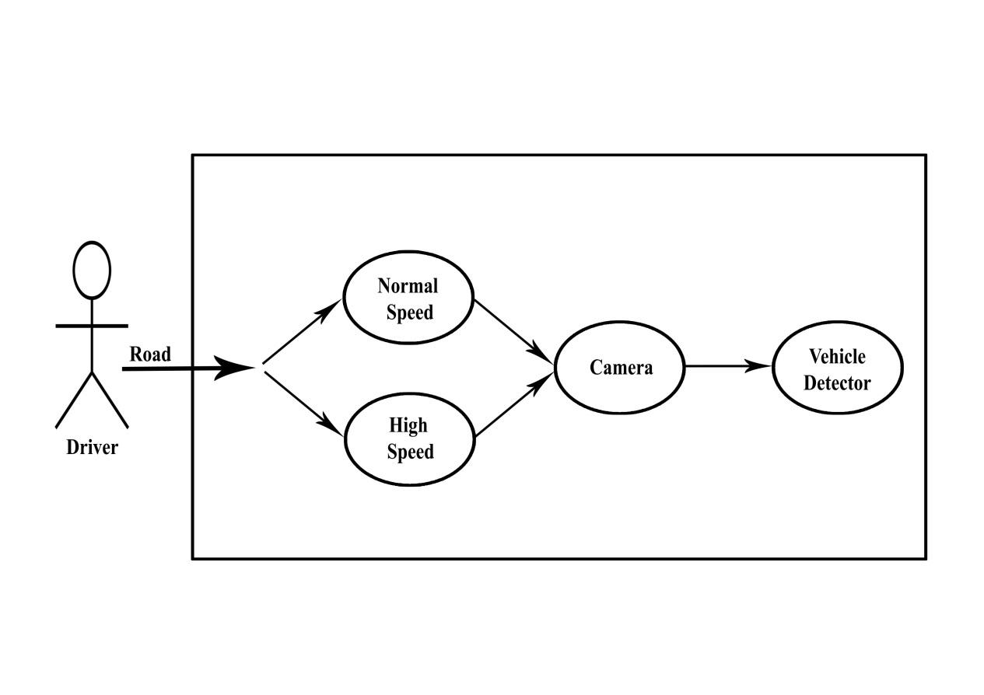

## Alternative Flows

### < First Alternative Flow >

#### < An alternative sub-flow >

### < Second Alternative Flow >

# Special Requirements

PHOTORESISTOR – Photo resistors also exhibit a certain degree of [latency](https://en.wikipedia.org/wiki/Latency_(engineering)) between exposure to light and the subsequent decrease in resistance, usually around 10 milliseconds.

# Preconditions

First Priority for this project is photo resistor which detects whether a letter is received or not.

The signal is been send by photo resistor to GSM Module and sent to the resident.

# Post Conditions

The detecting of letters in the Mailbox and transmits the alert message through the module.

# Extension Points

Going to provide details about the letter received.